SNMP Web BoX

ENGINEERING SPECIFICATIONS

Hardware specification
:: CPU
Freescale iMX280
:: Memory
NAND Flash – 128M Bytes
DDR2 – 128 MBytes
:: Ethernet Connector
10 / 100 BaseT RJ-45, auto switch.
:: Power Input and Consumption
12V DC regulated , power consumption under 3 watts.
:: Size
128.5 x 75 x 28 mm(L x W x H)
:: Network Interface
UTP Fast Ethernet 10/100BastT RJ-45, auto-sense
:: Serial Port
Two RS-232 ports. one used as a master to poll the EMD device
another is golden finger type serial port and connected to UPS.
:: Real Time Clock
Hardware real time clock and can be adjusted by SNTP.
:: Firmware Upgradeable
Upgrades firmware via a web browser or SSH/SCP

:: SSH Management
Allows management via SSH
:: Telnet Management
Allows management via telnet ,default disable

:: IPV4/6
Supports IPV4 and IPV6

::Battery
High-efficient capacitor. Exclusively provides power to RTC. After fully charged, it can provide 4-day power during power failure.

:: Reset jumper
It can reset to default factory setting for IP address and password.

::Data /Event log
Supports 200,000 threads of logs and 200,000 data logs. No data loss during power failure.

:: SNMP Network Management
Supports both SNMP v1 , v2c and V3, Supports RFC 1213 (MIB-II), RFC 1628 (UPS MIB) , and
private UPS extension MIB. Compatible with any standard SNMP NMS

:: Web Network Management
Supports HTTP , HTTPS , Combined with HTML.CGI

:: Operating Environment
0 to 70 degree C

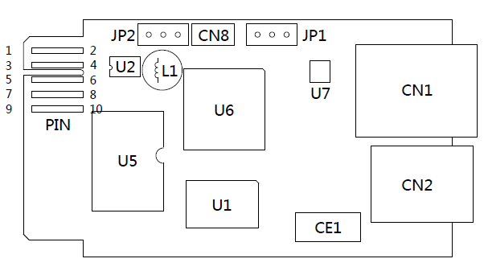

PIN : Golden finger
JP2: Debug port
CN8: USB FW burn port
JP1: Reset jumper
U2: Max 3232 RS232 clip
L1: Capacitance
U6:iMX280
U7:Ethernet transceiver
CN1:RJ45 Ethernet port
U5: 128MB Nand Flash
U1: 128MB DDR2
CE1:Battery
CN2:RJ11 RS232 port

Golden Finger Pin Define
Pin | Pin Descript
1 | GND
2 | +12V
3 | TXD
4 | RXD
9 | GND
5,6,7,10 | Not used

Pin assignment for JP1:
Pin # | Status | Description
Pin 1 & Pin 2 | Closed | Normal operation
Pin 2 & Pin 3 | Closed | After re-connecting utility, the IP address of SNMP web card and password will restore to default setting .The default setting is using DHCP, if there is no DHCP server ,the SNMP will use static IP address: (192.168.102.230)  Default password: 12345678

CN2 pin define

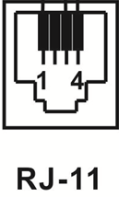
Pin | Descript
1 | GND
2 | +12V Power
3 | TXD
4 | RXD

