Conversion of CIRED paper into a feature article

Self-healing power distribution through zoning
In this article, Pekka MANNER, Kari KOIVURANTA, Antti KOSTIAINEN and Göran WIKLUND of ABB PPMV look at how the concept of zoning – a systematic method of dividing distribution networks into manageable areas based on loads, load criticality and disturbance vulnerability – can help improve reliability through the use of intelligent network nodes which cooperate seamlessly with substation and control centre systems.
System self-healing is nothing new in power distribution networks, where auto-reclosing and auto-reclosers have been used for decades – traditionally at the individual feeder level. With increasing demands for uninterrupted power from an ever- growing group of consumers, however, operators need a broader view of the whole distribution network and its capability to limit the impact of disturbances to as small areas and as few consumers as possible.
Dividing distribution networks into zones, separated by active and intelligent components, enables fault situations to be handled in an optimal way. Optimal in this context means as few affected consumers as possible, fast power restoration and with the involvement of as few personnel as possible. Central to this zoning concept are active and intelligent node components, data communication between these nodes and the substation, and control centre systems with appropriate software.
The fast development of technology in these areas – especially in communications – means it is now feasible to build advanced applications for zoning of this kind. This is particularly important for power utilities, as they face increasing demands for more reliable power supply and lower operational costs.

The zone concept
The structure of the power distribution network is influenced by population density, power consumption levels, the criticality of supply, legislation, environmental concerns, weather conditions, and the philosophy of the distribution network owner, among other factors.
For distribution network operators, the need to improve supply reliability and voltage quality, and to improve operational efficiency, are key drivers. In addition, the growing use of distributed, alternative energy sources makes network operation more complex, but also provides additional means to secure the power supply. All these factors make zoning a useful model for planning and upgrading distribution networks.
Figure 1 shows the various zones downstream of the substation as shaded areas. Located between these zones are zone dividers with protection and breaking/reclosing or simple disconnection capabilities. All zone dividers have facilities for remote communication to transmit the status indications, control commands, measurements, and so on, required by the application. Depending on the capabilities of the zone divider equipment, the zone on the downside is either a protection zone or a control zone.
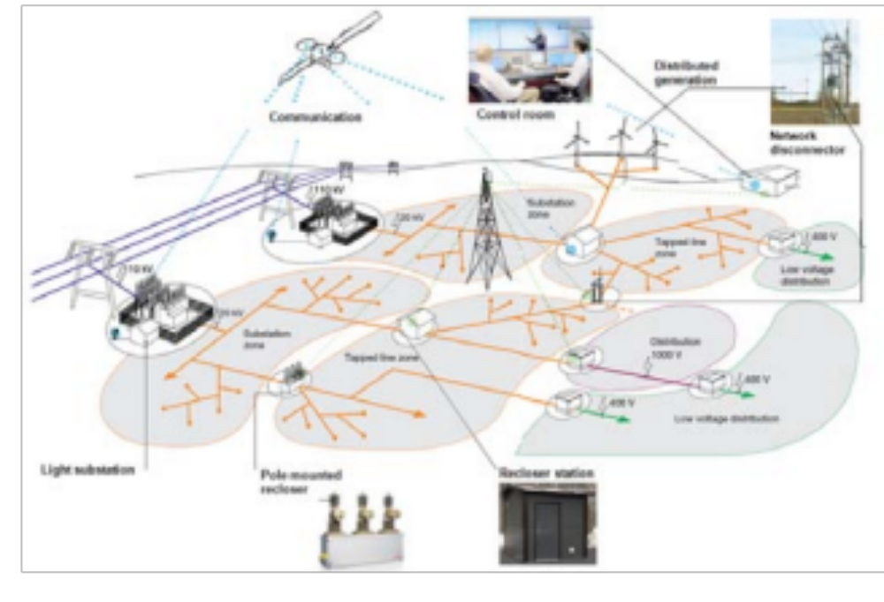
Figure 1. Main principles of zoning.

Protection and control zones
The zone borders are located according to the capability of the zone dividers, the differences in fault vulnerability between the areas and the criticality of the power supply within the areas. For example, areas can be differentiated according to fault probability, or the need to secure the supply to areas with substantial and/or critical consumption. The same criteria are used when determining whether a zone should be a protection zone or a control zone.
Circuit breakers and disconnectors are naturally among the most essential components in the distribution network. However, based on the need to secure the supply and reduce losses there is also an increasing use of distributed compensation equipment. Furthermore, there is, partly based on the need to have easy access and weather protection, an increased need to have ground mounted equipment, even if the network otherwise is built as an overhead line network.
In the application in Figure 2 the secondary equipment housed in a weather-proof enclosure is pole-mounted close to the ground level. The equipment handles protection, auto- reclosing, control and carries out versatile measurements. Communication with an upper level system is required in order to gain the full advantage of the automation.
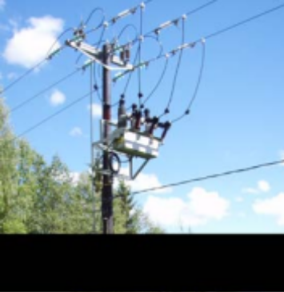
Figure 2. Traditional mounting of vacuum circuit breaker in an overhead line distribution network (pole-mounted recloser).

Figure 3 shows a weather-proof solution, which is especially suitable when more than one circuit breaker is needed at the same location. This type of solution is typically used when the main feeder has to be branched off into two feeders. The secondary equipment has versatile functionality for protection, auto-reclosing, control and communication.

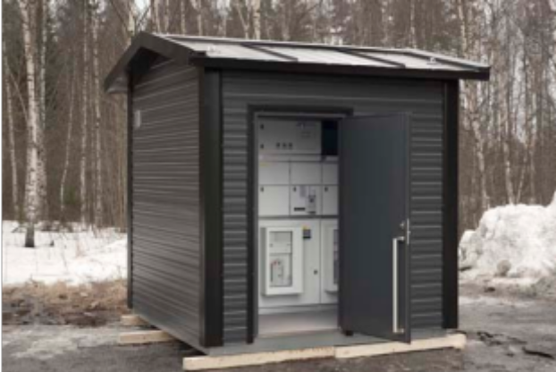
Figure 3. Ground-mounted vacuum circuit breaker application with one incomer and two outgoing feeders (recloser station), for either overhead or cable network.

Alternatively, a ground-mounted air-insulated load-break switch application with one incomer and two outgoing feeders (load-break switch station) can be used. Figure 4 illustrates an application with both recloser and load-break switch stations. Load-break switches can be used further out in the network, and the load-break capabilities are especially useful in network reconfiguration situations. As the load-break switch station is provided with the same secondary equipment as the recloser station, extensive measurements and control capabilities are available.

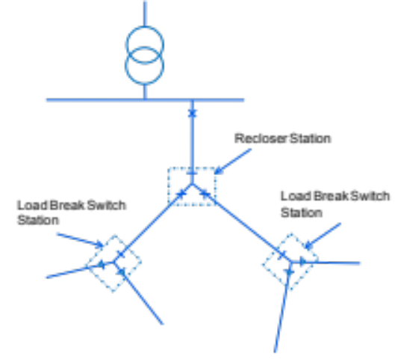

Figure 4. Principle location of recloser stations and load break switch stations in a main feeder.

Intelligent zone dividers
Continuing technology improvements have enabled the development of grid distributed secondary equipment with enhanced functionality – providing versatile measurement capabilities that support both operation and asset management, for example – in addition to protection. Local and remote control and automation features, as well as communication and auxiliary functions, are also provided in these all-in-one units. Zone dividers can be provided with exactly the right functionality for the application.
Communication is a central part of the zoning concept, as it is essential to know the status of the zone divider equipment and to control it. With the development of highly capable, widely available, reliable and secure public wireless networks, it is now feasible to implement communication capabilities in most nodes in a distribution network.

Substation and control centre software
While local automation has been a part of the distribution network for some time, the development of communication and the need for improved overview and control of the whole distribution network has given rise to centralized control and automation. The latest developments enable such functionality to be located at the substation level as well.
In the system shown in Figure 5, control and automation functions are located at local, substation and control centre levels. A system that takes into account the existing loads at various locations and the supply capability of alternative network configurations enables the implementation of fast, fully automatic fault localization, fault isolation, network reconfiguration and power restoration functionality – that is, the creation of a self-healing power distribution network.
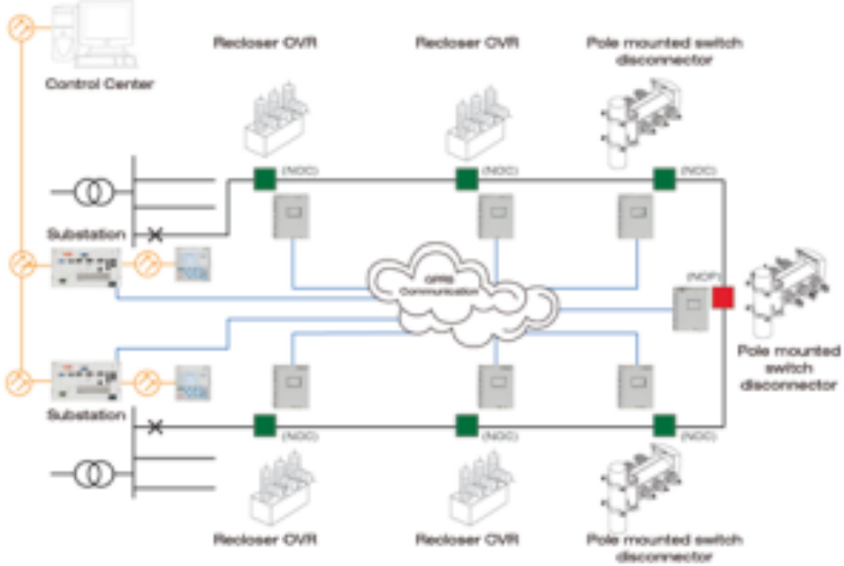
Figure 5. Automation functionality at different locations in a distribution network.

Pilot network
This zoning concept is being piloted on two rural area feeders in Kirkkonummi, Finland. The pilot project is divided into three phases. In the first phase, four new disconnectors and two new reclosers were installed into the distribution network and a local substation system into the primary substation. The devices are equipped with current sensors, which can supply data for the local substation system and for the distribution management system, for determining fault locations. The locations for the new devices were decided using feasibility calculations made with LuoVa, ABB's reliability analysis software, and on the basis of historical fault data.
In the second phase, the pilot is scheduled to cover other feeders of the same substation. In the third phase, a neighbouring substation is due to be included into the pilot so that the co-operation and back-up functionalities can be tested.
The original target is, besides verifying the functionality, to reduce the System Average Interruption Duration Index (SAIDI) – the total duration of interruptions to the average customer – by 50 percent. Currently the SAIDI is above 200 in the area, even though the automation level is quite high.
To find the most suitable locations for the zone dividers (breakers and switches), the team used both the LuoVa reliability analysis software and the historical outage/fault statistics from the DMS distribution network management system.
The DMS system can provide both the number of outages and their duration. Based on this historical data, as well as the fault probability from LuoVa analysis, the zone borders were determined for the Kirkkonummi pilot installation.
The piloted feeders have been divided into 20 remote-controlled disconnector protected areas and two remote-controlled recloser areas.
The feasibility of the concept pilot was also analysed with LuoVa, which was used to calculate customer interruption costs (CIC). Based on the Finnish regulation model, 50% of the reduced disturbance costs can be regarded as regulation income for the distribution company.
The results show that the first phase would achieve payback in six years (at an interest rate of 8 percent). The asset-based income allowed by Finnish regulation was not taken into account in the calculations, since there are no regulation definitions for new smart grid-related devices. With asset-based income, the payback time would be even shorter. The program does not take System Average Interruption Frequency Index (SAIFI) reduction into account either.

Choice of communications
The network automation devices use the public mobile network (GSM/GPRS) for communication with the substation computer. The substation computer communicates with the SCADA system, which cooperates with the DMS systems. The coverage of the public network was measured in the planned disconnector and recloser locations for verification of the availability of the network. Since the communication network depends on power supplied from the distribution network, it is important that there are several communication link stations available for the network automation devices, and that some of the link stations are supplied from a different distribution feeder.

Fault localization
Experience from other distribution network operators shows that the main challenge in automatic fault localization is to get the location of the fault with high accuracy. The reason for this is most likely that the majority of the faults in the network are earth faults, which cannot be located with earlier equipment. In the pilot installation this problem has been addressed as follows.
First, an intelligent fault location package for the DMS has been developed for the substation. This package includes:
- Localization of earth faults using new algorithms and graphical methods
- Disconnectors provided with current transformers, used as fault indicators
- Utilization of the fault indicator information in the DMS fault localization functions
- Triggering of the fault recorder including the Fault Locator (FLOC) function and combining it with the protection start signals. This enables possible fault locations are delivered to the DMS system before the faults cause an auto-reclose function and/or breaker trip.
Second, the DMS system will be provided with additional functionality, including:
- Localization of auto-reclosings (for example, all auto-reclosings in a week will be localized simultaneously)
- Display of the auto-reclosing frequency by feeder and by time period.
- Calculation of the FLOC parameters.

Automatic fault detection, isolation and restoration (FDIR)
For FDIR, the DMS system performs the following operation sequence.
The SCADA system provides the DMS system with the 'fault package' and the status of possible fault indicators. The DMS system locates the fault and creates a switching sequence for isolation of the fault and for restoration of the power supply using alternative supply routes (back-feed). The switching sequence is sent to the SCADA system for realization and the SCADA system implements it automatically. This is done step by step: the sequence does not proceed to the next step until the position indication has been received from the switching device. Tripping of a breaker during the sequence will stop the sequence.
One key question is where to locate the FDIR functionality. In the first phase of the pilot installation, the DMS system was central to providing FDIR functionality. The DMS system provides accurate and reliable information about the network situation. When a switching sequence is created, factors such as network loads, open connections, occasional earthings and ongoing construction work have to be taken into account. Solutions in networks including Distributed Energy Resources (DER) and demanding data maintenance issues are somewhat easier to handle in a reliable and dependable way in the centralized DMS system.
In the second phase of the pilot, however, the feasibility of running the FDIR functionality in the substation system is being tested. With this decentralized DMS/FDIR approach, the central system does not need to be directly involved in the process related to a specific substation. The feasibility of such a solution depends on the capabilities of the selected systems and their ability to work together.

Conclusion
The ability of the system to locate earth faults with high enough accuracy is a key issue when striving to reduce SAIDI figures. The reduction can be achieved when the fault locator functionality of modern protection relays is combined with information from network distributed fault indicators. With a DMS system that can create reliable switching sequences automatically and cooperate with the SCADA systems in place, further improvements will be focused on the division of the network into zones and the selection of the zone dividers.
Another key issue is the quantity and quality of the data transferred to the control centre. Advanced station-level fault management reduces the quantity and improves the quality of the data sent to the operators. This enables the control centre to focus on more important issues and overall coordination tasks.
The payback period of the pilot project is expected to be six years. The zoning concept is being piloted in a network that already has a relatively high level of automation. The payback period would be even shorter in a network with a lower automation level.
The creation of such zoned distribution networks is one of the first key steps towards an automated, self-healing network.

[2,200 words]

