VirtualArc® - a unique tool
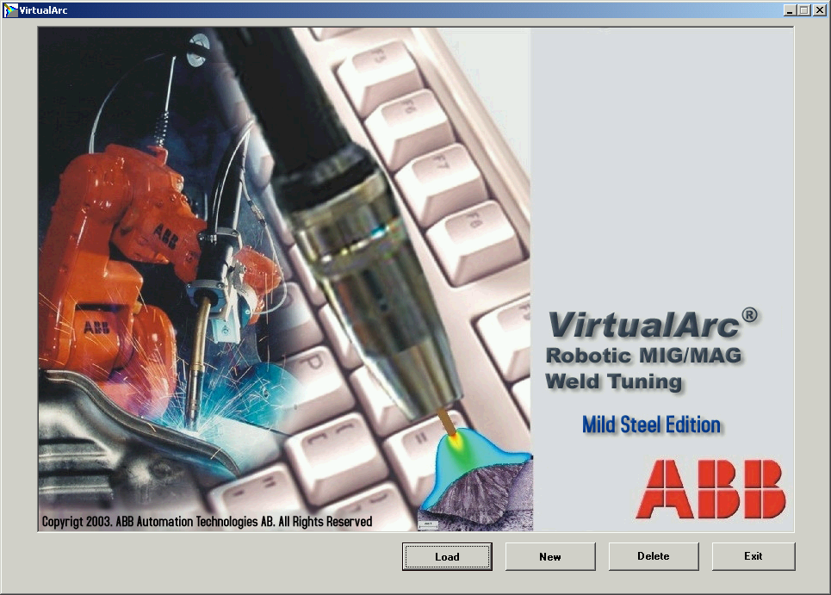

Robotic MIG/MAG Off-line Weld Tuning
The VirtualArc® is a software tool giving the
Robot Welding Engineer full control if the MIG/MAG
process in off-line environment.

For more information please contact:
ABB Automation Technologies
Robotics, Automotive & Manufacturing,
Arc Welding Products
Contact Person: Dick Skarin, Senior Product Manager
Tel: +46 584 81596
dick.skarin@se.abb.com

VirtualArc® offers robot programmers, operators and
welding engineers an expert system with deep arc welding
process know-how, which gives the possibility to improve
process control, final welding quality and productivity.
The system offers a user-friendly software interface, which will minimize process implementation time and costs of automated arc welding.

Arc Welding Process Simulation technology
The technology behind the VirtualArc® software is based on the combination of arc physics, self-consistent two-dimensional wire-arc-work piece simulation tool, arc welding practical experience and experimental measurements.
The software consists of different modules that are strongly inter-connected in the whole process system, including power source characteristics and connecting cables.
Weld profile and quality predications are obtained using Bayesian Neural Network tool. Predictions from arc simulations, heat and mass transfer to the work-piece, are used as input to the neural network to predict weld quality and profile as well as defects.
The VirtualArc® software
For given welding configuration, VirtualArc®
will simultaneously recommend the optimum
welding speed and wire feed rate together with
a prediction of the size and shape of the fusion zone.
This predictive capability allows the user to
extensively test different combinations of weld
parameters and equipment. The user can also
assess results by looking at the system´s
confidence in maximum and minimum tolerance
limits overlaid on the predicted weld profile.

VirtualArc® features and benefits
- Saving time & money in connection to robotic arc welding process implementation
- Excellent tool for off-line process support and service
- Efficient training tool for robot, operators, programmers & production/ welding engineers.
- Better optimized welding productivity, resulting in lower product cost for the user
- Better optimized welding quality, resulting in lower product cost for the user
- Efficient productivity tool for comparing different weld procedures, in cost/ meter weld
- Platform for retrieving & storing arc welding process know-how for future process developments.

ABB strongly believes that the need of tools like VirtualArc® will become more and more important in the future as the number of welding engineers and welders are decreasing and will decrease even more in the future, specially among young people. This trend within the arc welding is already today one of the biggest obstacles for introduction of automatic welding and will become an even larger obstacle in the future.
VirtualArc® software and technology introduction is seen by ABB as one important step forward to help both existing and future arc welding robotic customers to automate their production in a efficient way.
Currently, the VirtualArc® software tool will be introduced to the market as a “ first edition” with two different sizes of the same power source with the market name ARCITEC ll. The material option will be mild and low tensile steel, and the wire selection will be normal Solid wire, of SG 2 type, with the following dimensions 0.8, 1.0, 1.2, 1.6 mm.
The “ first edition” will also include the selection of two common shielding gas mixtures.
Future expansion of the system will be made in cooperation with end users and suppliers, based upon their specific requirements for new application areas.
In first hand this will give the potential to simplify the use of arc welding robotics in the manufacturing industries.

For more information please contact:
ABB Automation Technologies
Robotics, Automotive & Manufacturing,
Arc Welding Products
Contact Person: Dick Skarin, Senior Product Manager
Tel: +46 584 81596
dick.skarin@se.abb.com

