NOTE
Administrator need to be granted with Recipient Management access permission in order to perform user device wipe.

How to wipe device – user
- Login to OWA
- Go to options
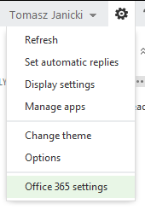
- Go to Phone
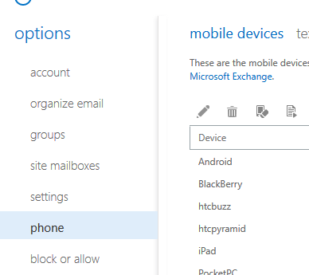
- Select Device you want to wipe and click Wipe icon
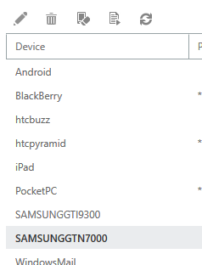
- Select Yes if you want to wipe your device
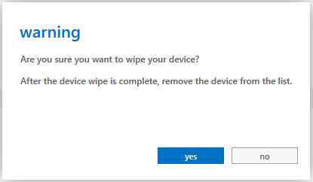
- Once device will connect with exchange it will be automatically wiped
- Once device will be wiped you will get email with wipe notification
The remote device wipe completed successfully.
The remote device wipe initiated on 07/04/2013 11:43:01 is complete.
Device type: SAMSUNGGTI9300
Device ID: SEC1A416ADF6C1C4
Note: To sync with the server, you must remove this partnership from the list of mobile devices in Outlook Web App.
Otherwise, for security purposes, your mobile device will continue wiping data if you try to sync again.
- You need to remove device from you list in order to use it again otherwise device will continue to wipe every time you connect this device to Exchange
- Select device you just wiped and press Bin icon to remove it.

How to wipe device through Shell – administrator
- login to Shell
- List user device - Get-MobileDevice -mailbox "Tomasz Janicki" | select identity
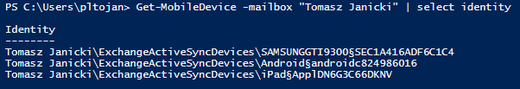
- To wipe user device choose device from the list and use it as Identity is this script:
eg. Clear-MobileDevice -Identity “Tomasz Janicki\ExchangeActiveSyncDevices\SAMSUNGGTI9300§SEC1A416ADF6C1C4” -NotificationEmailAddresses admin@pl.abb.com
note: -NotificationEmailAddresses parameter specified to who notification about wipe will be sent is good to send this notification to your self as once device will be wiped it need to be removed from exchange

- Then you will be asked if you really want to wipe this device – press Yes to all
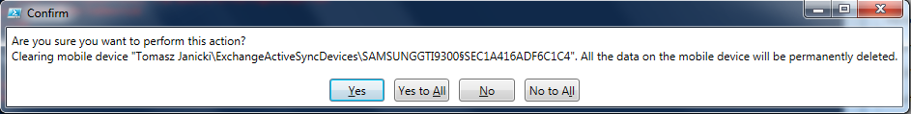
- Once device will be wiped it need to be removed from exchange in order to use it again
Remove-MobileDevice -Identity "Tomasz Janicki\ExchangeActiveSyncDevices\SAMSUNGGTI9300§SEC1A416ADF6C1C4"
- Then you will be asked if you want to remove this device – select Yes to all
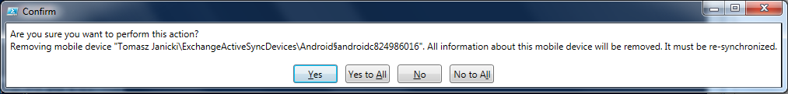

How to wipe device through EAC
- login to EAC - http://portal.microsoftonline.com/
- Switch view to Exchange
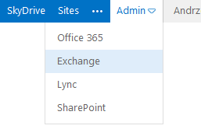
- Under Recipients > Mailboxes search for the user that you want to wipe device
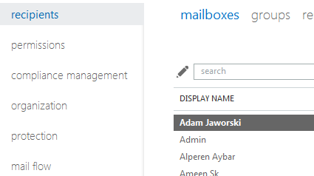
- Once user will be selected on the right under Mobile devices click on View details
- Select device that you want to wipe and click Wipe icon
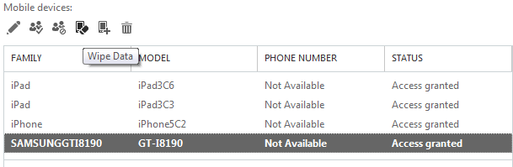
- Press OK on notification message
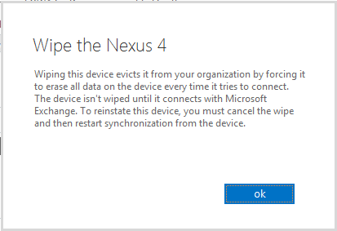
- Then press Save to process your request
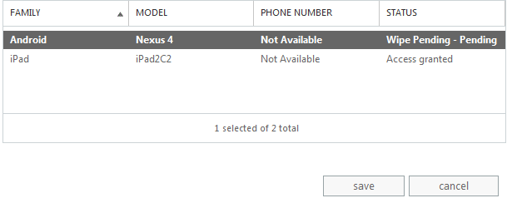
- Once device will be wiped it need to be remove from exchange in order to use it again. To delete it select device and click on Bin icon to remove it and then press Save.
