Retrofitting auto-mooring winches on Viking Line’s m/s Mariella

With room for 2,500 passengers and 450 cars, a disco, a casino, restaurants and shopping, Viking Line’s cruise ship the m/s Mariella is a floating family entertainment experience providing service between Helsinki and Stockholm.

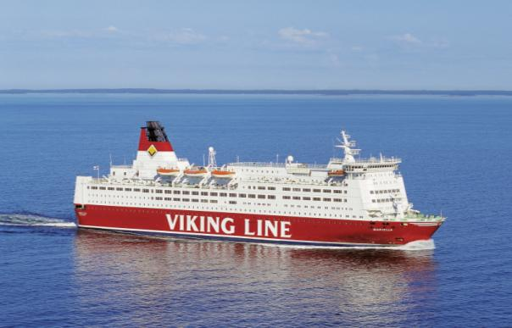

Existing three speed electric motor winch control
When the ship arrives in port, the ship’s winches keep it secure to the dock so the passengers can safely board and depart the ship and the cars and trucks can be loaded and unloaded. The ship’s six winches, in operation since 1985, use a three-speed control system with three-winding, direct-on-line (DOL) motors and an external mooring controller and load sensor in the gearbox.

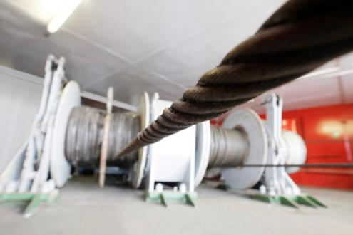
In operation since 1985, the m/s Mariella’s winches keep the ship securely docked.

Using this system to moor the ship, winch operators watch the rope until it is taught, adjusting the speed of the winch accordingly. Each speed change made to the winch (low, middle, or high speed) results in a direct-on-line start of one of the motor’s windings. DOL starting combined with the high torque demands of the mooring operation place substantial stress on the winch system, and as a result, rotors on the winch motors would break periodically. In addition, the age of the winches makes finding spare parts more difficult, typically some spare parts could have long delivery times, especially for the motor parts.

“The old system is breaking the motors, when we are in the harbor, when we have torque control, it’s going on and off all the time. It’s full ahead or nothing.” says Jonas Rautelius, the ship’s electrician.

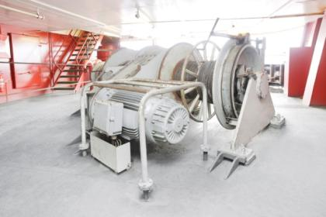
The m/s Mariella’s winch used a 3-speed control system with a 3-winding motor.

Contactors used to start the motors direct-on-line are also prone to failures, adding to the maintenance of the ship. Contactor failure also could result in a potentially dangerous situation for winch operators. If the winch is bringing in the rope and a contactor fails, it is possible for the rope to continue to spin around the winch’s drum, uncontrolled, until the main power could be disconnected.

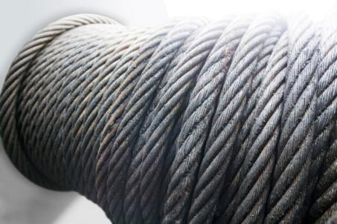

Modernizing winch control
Already familiar with ABB drives that are used in other applications onboard the m/s Mariella, Jonas decided to contact ABB to find out about using AC drives for winch control. He was interested in finding a stepless speed and torque solution that could replace the three-speed system and would also reduce maintenance costs and eliminate the direct-on-line starting current peaks. He was also looking for a solution that had built-in winch control instead of requiring additional external components, such as a tension controller. With the spare parts becoming more difficult to find, using a drive would reduce the mechanical stress on the winch system. This in turn would reduce maintenance demands, costs, and the need to obtain the hard to find spare parts.

After meeting with ABB, Viking Line decided to evaluate and test ABB’s proposed solution and agreed to retrofit one winch. Using the ship’s drawings from 1985, ABB specified the marine certified ACS800-01 industrial drive with the built-in winch control program that allowed the m/s Mariella to keep the existing three-winding motor, motor cable, and operator control stands. “It was quite cheap to do it like this” says Jonas. “This is a big factor in deciding to do the rest.” The drive’s IP55 enclosure permitted it to be mounted directly to the wall of the ship, no additional enclosure cabinet was required. This also lowered the retrofit costs.

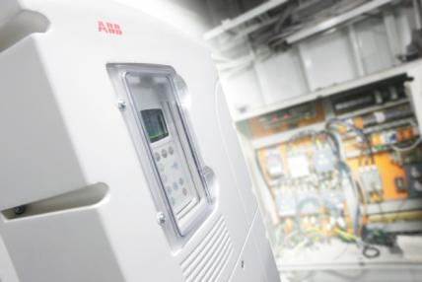
The ACS800 mounted on the ship’s wall, with the old contactor enclosure the drive replaced in the background.

Drive commissioning started once the ship left the harbor in Helsinki, and within four hours, it was ready for operation. The new system was put to the test when the ship arrived in Stockholm the following morning.

Measuring torque allows auto-mooring without load cell sensors
Because the drive uses ABB’s direct torque control (DTC), the solution does not rely on external sensors such as a load cell sensor in the gearbox or encoder on the motor. DTC allows open-loop control of the winch motor which permitted the m/s Mariella to keep and reuse the existing winch motor, without having to install an encoder. The winch control program in the drive uses the DTC motor control technology combined with patented winch application torque measuring logic to measure the rope’s tension and calculate the required torque at every start.

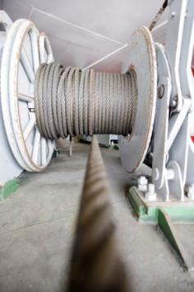
The drive’s patented winch application’s torque measuring logic maintains rope tension without using a load cell.

Easier operation
With the ABB solution, as the ship arrives in harbor, the winch operation starts with the drive in hand-mooring control to quickly and smoothly let out the rope at a high speed. When the rope is connected to the harbor, the winch brings in the slack rope quickly, until the winch control program’s peak torque protection function automatically stops the hand-mooring operation when the defined torque limits are reached. Winch operators then switch the control to the auto-mooring mode.

Auto-mooring mode keeps the tension
In auto-mooring mode, time control sequences are used to monitor the rope’s tension, keeping the ship secure. One time control sequence is used while loading and unloading the vessel, where the drive monitors and adjusts the rope’s tension very frequently (for example, once every 30 seconds). Then, after the vessel has been unloaded, a longer time control sequence can be used to check and adjust the tension less often (for example, every 120 seconds).

A potentiometer on the control stand is used to adjust the auto-mooring set point (rope tension) for the drive to maintain. “The best thing is that we don’t have to touch it anymore.” says Jonas. With a few months of testing completed, he added that “It’s easier, winch operators can just put the auto-mooring with torque control on and leave the winch. With the old system, they had to constantly see if the rope was tight.”

Integrated mechanical brake control
m/s Mariella’s winch motors have a parking brake that is engaged when the winch is not operating. The ACS800 drive’s built-in winch control program provides synchronized brake control with the winch operation’s start and stop commands. Brake control is integrated into the winch’s brake circuit through a relay output on the drive. Before the brake is closed, the drive ensures the disc brake is closed before stopping the drive’s torque control. When opening the brake, the sequence is reversed, the drive determines and brings the motor to the needed torque to hold the rope’s tension, and then opens the brake.

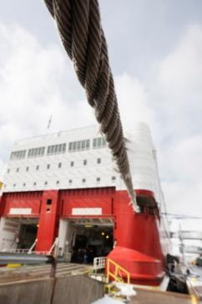
The auto-mooring program automatically maintains m/s Mariella’s rope tension while the ship is in harbor.

Drive reduces stress
The drive’s soft starting and stepless speed and torque control eliminated the direct-on-line electrical startup peaks. “We don’t have the peaks on the main electrical board anymore,” Jonas says happily. With the cabinet of contactors replaced by the drive, the maintenance burden of the ship’s staff is reduced, lowering operating costs. With no contactors to fail, the drive also eliminates a potentially dangerous hazard for the winch operators.

Cost efficient retrofit
This cost efficient retrofit solution allowed Viking Line to upgrade from three-speed to stepless winch control while keeping the existing winch motor, motor cable and operator control stands.
They were able to eliminate an electrical cabinet of contactors, the external mooring control unit and the external load cell sensor. The stepless control of the motor speed and torque along with the soft starting of the motor will save significant motor repair costs and reduce stress on the ship’s electrical network. From the operator’s point of view, Jonas reports that the winch operators “would like every winch to be like this.”

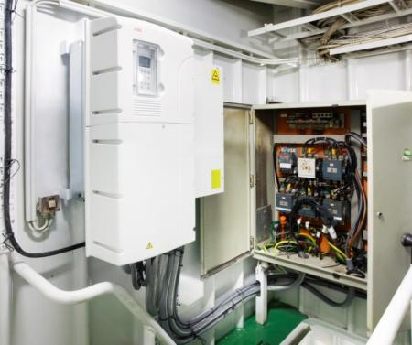
The ACS800 and the du/dt filter mounted on the ship’s wall. The optional du/dt filter protects the old motor’s windings.

ABB (www.abb.com) is a leader in power and automation technologies that enable utility and industry customers to improve their performance while lowering environmental impact. The ABB Group of companies operates in around 100 countries and employs about 145,000 people.

Article contact information:
Mr. Mikael Holmberg
ABB
Market Manager, Cranes and Winches
LV AC Drives
PO Box 184
FIN-00381 Helsinki
Finland
+358 50 332 3848
Mikael.holmberg@fi.abb.com

