ABB Learning Zone 2013 Courses Calendar
Course Code Course Description Days Course Dates Cost
T308 | System 800xA with AC800M –Hardware Maintenance and Troubleshooting | 5 | 17-21 March / 21-25 April / 20-24 October | On request
T309 | System 800xA Safety - AC800M High Integrity Configuration and Maintenance | 4 | 4-7 March/ 17-20 June / 28-31 October | On request
T315C | System 800xA Engineering using Control Builder | 5 | 3-7 February / 17-21 February / 15-19 September / 29 Sept-3 October | On request
T315H | System 800xA HMI Configuration | 5 | 10-14 March/ 6-10 October | On request
T321 | System 800xA for Harmony Configuration | 5 | 10-14 February | On request
M111 | Harmony Rack I/O with Composer | 5 | 24-28 March | On request
M201 | Symphony Harmony Basic with Composer | 5 | 7-11 April | On request
M202 | Symphony Composer Engineering Tools | 5 | 23-28 June | On request
M211 | S800 I/O for Harmony Controllers | 5 | 9-14 June | On request
M304 | Harmony Function code Configuration | 5 | 23-27 June | On request
T142 | Functional Safety TUV Certification | 4 | 29 April- 03 May / 11-14 November | On request
E143 | 800xA Troubleshooting Core System | 5 | 19-24 May | On request
E144 | 800xA System Health Check | 5 | 26-30 May | On request
T560 | Freelance (AC 800F) –Maintenance and Configuration | 5 | 12-17 May | On request
T568 | Freelance System Engineering | 5 | 07-11 April /22-26 September | On request
T561 | Freelance - Operation with Digivis | 2 | 14-15 April | On request
T317 | Foundation Fieldbus |  | On request | On request
T315F | System 800xA Engineering using Function Designer | 5 | On request | On request
M302 | INFI 90 BATCH 90 Language | 5 | On request | On request
M203 | Conductor NT HMI Configuration | 5 | On request | On request
SC300E | Triguard Training course CS300E | 3 | On request | On request
AR104 | Plantguard Basic Engineering and Maintenance | 5 | On request | On request
GPBG01 | Plantguard Maintenance and Trouble shooting | 5 | On request | On request
GPBG02 | Plantguard Engineering | 5 | On request | On request
GPBG03 | Plantguard Administration | 3 | On request | On request
T530 | Compact Control Builder AC 800M - Configuration | 5 | On request | On request
T310 | System 800xA HMI Operation | 2 | On request | On request
Z457 | NGC8201 + NGC8206 / PGC1000 | 5 | 23-29 March / 22-28 June / 14-19 July / 20-26 September / 13-17 October | On request
Z401/460 | PGC2000 + VistaNet | 5 | 13-19 April | On request
Z516 | CGA Advance Optima | 5 | 26-30 May / 22-27 August/ 03-08 November | On request
ABB Tropos | Certification Training | 4 | 07-10 April / 06-09 April | On request
Training for professional Engineers | Process Safety management leadership | 2 | On request | On request
Training for professional Engineers | Safety Management best practice | 5 | On request | On request
Training for professional Engineers | An Understanding of Process Safety Management Systems | 2 | On request | On request
Training for professional Engineers | Hazard Study Awareness | 3 | On request | On request
Training for professional Engineers | Hazard Study Leader's course | 5 | On request | On request
Training for professional Engineers | Human Factors Incident Investigation | 2 | On request | On request
Training for professional Engineers | Alarm Management | 3 | On request | On request
Training for professional Engineers | Safety Integrity Level (SIL) Determination | 3 | On request | On request
Training for professional Engineers | Electrostatic Ignition Hazards | 2 | On request | On request
Training for professional Engineers | Managing Deterioration of Process Equipment | 3 | On request | On request
Training for professional Engineers | Managing Asset Life Planning | 4 | On request | On request
Training for professional Engineers | Essentials of Pressure Systems | 3 | On request | On request
Training for professional Engineers | Design and operation of Piping Systems | 3 | On request | On request
Training for professional Engineers | Pressure Relief | 4 | On request | On request
Training for professional Engineers | Mechanical Failures of Rotating Equipment | 4 | On request | On request
Training for professional Engineers | Machine Condition Monitoring and Predictive Maintenance | 2 | On request | On request

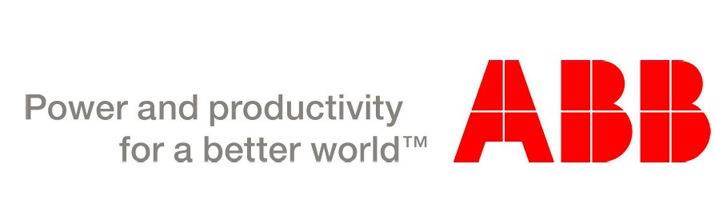
Training for professional Engineers | Reliability Improvement Tools Workshop
Training for professional Engineers | Root Cause Analysis | 2 | On request | On request
Training for professional Engineers | Critical Analysis and FMECA | 2 | On request | On request
PLC | AC500 Basic Training | 2 | 08-09 April / 07-08 September | On request
G156 | ACS800-X7 single drive, start-up, maintenance and service hands-on training | 2 | 20-21 February /20-21 March / 16-17 April / 08-09 May/ 11-12 September / 13-14 November | On request
R106 | IRC5 Operator Course(Robotics) | 2 | 25-26 May / 26-27 June | On request
INTCV163 | Operation and Maintenance of Distribution Transformers | 2 | On request | On request
P114 | REF542plus Feeder Protection & Control IED - Operation & Maintenance | 3 | 04-07 March /01-03 July /29-30 October /23-25 December | On request
P261 | Relion® 615 Series - Operation & Engineering | 2 | 10-11 March / 09-10 June /22-23 September /08-09 December | On request
P263 | Relion® 630 Series - Operation | 1 | 12 March / 11 June / 24 September/ 10 December | On request
P264 | Relion® 630 Series - Programming | 2 | 13-14 March / 12-13 June / 25-26 September / 11-12 December | On request
P269 | Relion® PML630/cPMS - Programming | 4 | 18-21 March /17-20 June /30 Sept-03 October /16-19 December | On request
P232 | REF 543/545 - Operation | 1 | On request | On request
P233 | REF 543/545 - Programming | 2 | On request | On request
P235 | REF 542plus - Operation | 1 | On request | On request
P236 | REF 542plus - Programming | 2 | On request | On request
CZ021 | Unigear ZS1 Operation and maintenance with VD4 and REFXXX | 5 | 24-28 March /23-27 June /06-10 October /22-26 December | On request
O406 | Unigear ZS1 Installation and maintenance (on Site) | 1 | 01-April / 04-July / 29-September /15-December | On request
O401&O402 | Unigear ZS1 switchgear introduction and operation | 1 | 07-March/30-June/ 19-September /05-December | On request
G300 | Gas Insulated Switchgear (GIS) ZX series - Operation and maintenance | 2 | 25-26 February/ 23-24 April/ 18-19 June /22-23 October | On request
TEC | Transformer online monitoring | 1 | 04-March/01-July /18-September/16-December | On request
UAE750 | SF6 Handling training (Local course) | 1 | On request | On request

3 On request On request

